Key to genera of New World Rhypariini (Scarabaeidae: Aphodiinae)

1. Mesotibia with subapical notch and tooth on inner margin (Fig. 1) ……………..… 2
1'. Mesotibia with inner margin entire; if present, mesotibial tooth at apex (Fig. 2) … 3

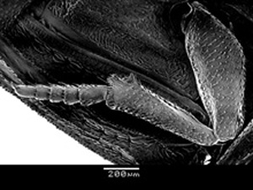 |  | 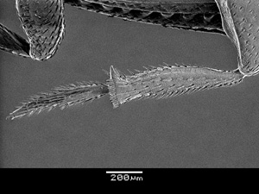
Figure 1. Aschnarhyparus peregrinus |  | Figure 2. Rhyparus mexicanus

2(1). Meso- and metatibiae flattened, triangular in cross section (Fig. 3). Pronotal carina sharp, uniform height throughout length ……………………. Aschnarhyparus Makhan
2'. Meso- and metatibiae more cylindrical, circular in cross section (Fig. 4). Pronotal carina swollen; more prominent, bulbous anteriorly …………. Termitodius Wasmann

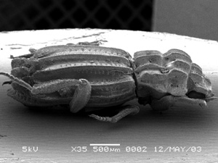 |  | 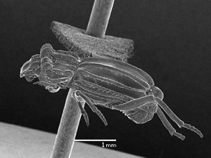
Figure 3. Aschnarhyparus peregrinus |  | Figure 4. Termitodius coronatus

3(1). Elytra not parallel-sided (Fig. 5), short, not more than 2 times longer than pronotum
…………………………………………………………………. Nanotermitodius Howden
3'. Elytra parallel-sided, long, but 2.5 times longer than pronotum (Fig. 6) …………… 4

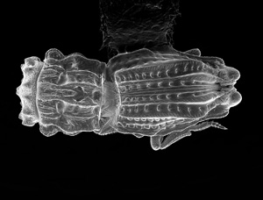 |  | 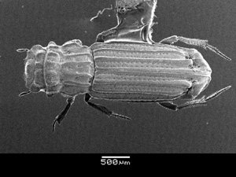
Figure 5. Nanotermitodius peckorum,  from Howden 2003. Thanks and credits to Jennifer Read, Agriculture Canada |  | Figure 6. Rhyparus opacus

4(3). Discomedial carina of elytra lacking distinct setal tuft immediately anterior of apical trichomes …………………………………………………………… Rhyparus Westwood
4'. Discomedial carina of elytra with distinct, narrow setal tuft immediately anterior of apical trichomes (Fig. 7-8) ……………………………………… Leptorhyparus Howden

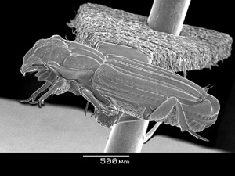 |  | 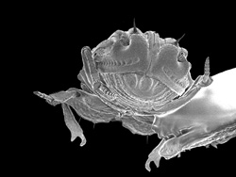
Figure 7. Leptorhyparus sp. |  | Figure 8. Leptorhyparus sp.

