Key to genera of New World Psammodiini (Scarabaeidae: Aphodiinae)

1. Apical clypeal angle with 1 small, sharp, clearly upturned tooth on each side of apical emargination (Fig. 1) …………………………………………………………………... 2
1'. Clypeus rounded or angled at each side of median emargination, always lacking teeth (Fig. 2) …………………………………………………………………………………. 5

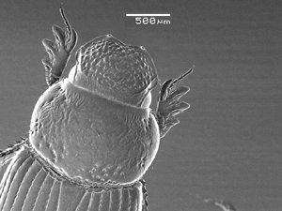 |  | 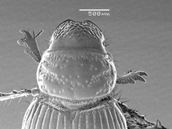
Figure 1. Odontopsammodius cruentus. |  | Figure 2. Tesarius caelatus.

2(1). Dorsal surface lacking setae …………………………………………………… 3
2'. Dorsal surface with setae throughout (Fig. 3) ……………………………………… 4

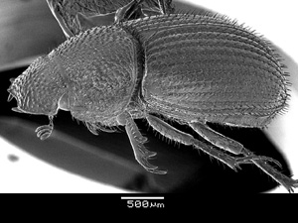
Figure 3. Trichopsammodius brasiliensis

3(2). Body robust, somewhat globose (Fig. 4). Basal metatarsomere short, triangularly expanded ……………………………………… Odontopsammodius Gordon and Pittino
3'. Body elongate, somewhat cylindrical (Fig. 5). Basal metatarsomere weakly shortened, widened apically, usually not notably triangular
………………………………………… Parapsammodius Verdú, Stebnicka and Galante

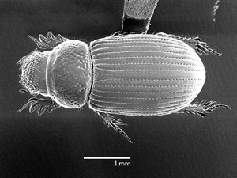 |  | 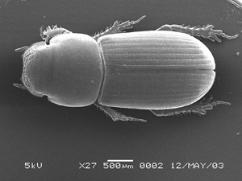
Figure 4. Odontopsammodius cruentus. |  | Figure 5. Parapsammodius pseudointeger.

4(2). Pronotal punctures large, simple, with depressed setal pore. Elytral setae prominent (Fig. 6). Metafemur broad, wider than profemur. Metatarsomeres strongly, obviously asymmetrically widened apically …………………...…….. Trichiopsammodius Petrovitz
4'. Pronotal punctures very large, appearing O-shaped, with small central tubercle bearing setae. Elytral setae short, indistinct (Fig. 7). Metafemur slender, obviously narrower than profemur. Metatarsomeres moderately, asymmetrically widened apically
………………………………………………………………………… Mysarus Petrovitz

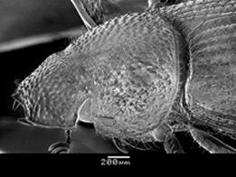 |  | 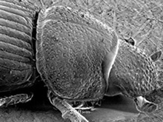
Figure 6. Trichopsammodius brasiliensis. |  | Figure 7. Mysarus peruanus.

5(1). Metatibiae with distinct transverse carina (Fig. 8) ……………. Tesarius Rakovic
5'. Metatibia lacking transverse carina, rarely with weak transverse line, often with row of setiferous teeth (Fig. 9) …………………………………………………………….. 6
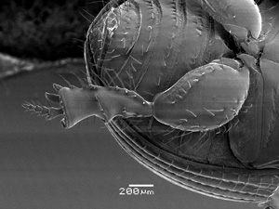 |  | 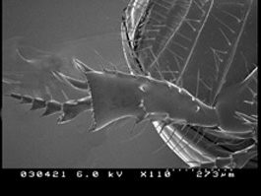
Figure 8. Tesarius caelatus. |  | Figure 9. Geopsammodius rileyi.

6(5). Pronotal sculpture with at least 5 transverse ridges (Fig. 10), ridges either continuous or broken into discrete granules, usually with as many transverse furrows ...7
6'. Pronotal sculpture with at most 3 weak, rarely with vague 4, transverse ridges and furrows (Fig. 11) ……………………………………………………………………… 11
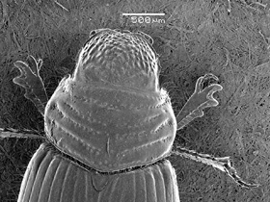 |  | 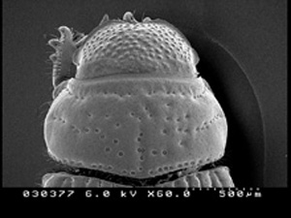
Figure 10. Psammodius basalis. |  | Figure 11. Leiopsammodius malkini.

7(6). Metatarsomeres with at least basal segment short, broad, strongly asymmetrically widened apically (Fig. 12) …………………………………………………………….. 8
7'. Metatarsomeres elongate, basal segment subcylindrical (as in Fig. 13), slightly symmetrically or asymmetrically widened apically …………………………………... 9
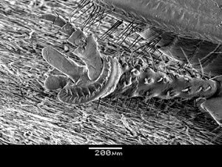 |  | 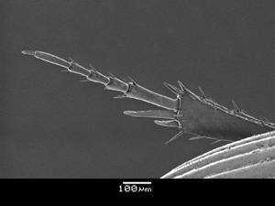
Figure 12. Psammodius basalis. |  | Figure 13. Pleurophorus caesus.

8(7). Vertex of head with 1 or 2 pairs of oblique ridges arranged in chevron (Fig. 14), ridges either continuous or broken into discrete tubercles …………. Psammodius Fallen
8'. Vertex of head without oblique ridges (Fig. 15) …………. Neopsammodius Rakovic

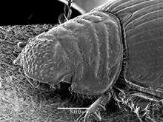 |  | 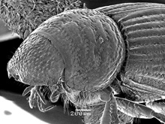
Figure 14. Psammodius basalis. |  | Figure 15. Neopsammodius werneri.

9(7). Elytra with scale-like setae on raised intervals (Fig. 16) .. Trichiorhyssemus Clouët
9'. Elytra lacking setae ………………………………………………………………. 10

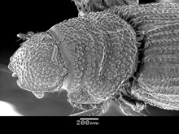
Figure 16. Trichiorhyssemus riparus.

10(9). Vertex of head with 1 or 2 pairs of oblique ridges arranged in a chevron, ridges either continuous or broken into discrete tubercles (Fig. 17). Pronotal margins obviously setaeous. Elytral intervals either flattened or costate with distinct rows of fine to coarse tubercles ………………………………………………………….. Rhyssemus Mulsant
10'. Vertex of head without oblique ridges (Fig. 18). Pronotal margins lacking setae. Odd elytral intervals strongly costate, even intervals flat, both lacking tubercles
………………………………………………………. Neorhyssemus Gordon and Pittino

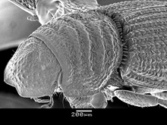 |  | 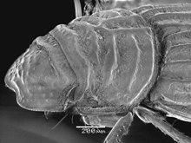
Figure 17. Rhyssemus germanus. |  | Figure 18. Neorhyssemus quinquecostatus.

11(6). Body short, robust, visibly dilated posteriorly (Fig. 19). Elytral base not margined. Posterior tarsus short, tarsomeres 1-4 triangular (Fig. 20) ……………………………..12
11'. Body slender, elongate, either suboval or subparallel, slightly dilated posteriorly (Fig. 21). Elytral base margined. Posterior tarsus elongate or somewhat shortened, all tarsomeres elongate or with basal 1 or 2 segments asymmetrically widened apically (Fig. 22) …………………………………………………………………………………….. 13

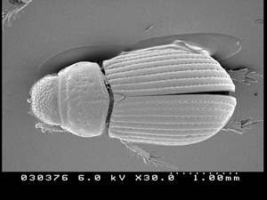 |  | 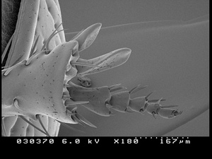
Figure 19. Leiopsammodius malkini. |  | Figure 20. Leiopsammodius malkini.
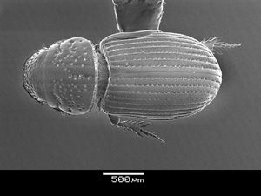 |  | 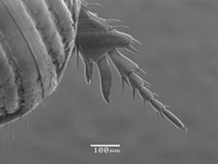
Figure 21. Platytomus micros. |  | Figure 22. Platytomus micros.

12(11). Eye normal. Frontal suture usually distinct (Fig. 23). Tenth elytral interval reaching apical third (Fig. 24). Wing normally developed. Claw corneous
……………………………………………………………… Leiopsammodius Rakovic
12'. Eye small, poorly developed. Frontal suture apparently lacking (Fig. 25), vertex lacking transverse ridge. Tenth elytral interval short, only attaining middle of eltyra (Fig. 26). Wing vestigial. Claw setaceous ……………. Geopsammodius Gordon and Pittino
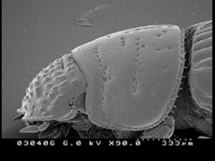 |  | 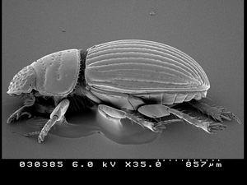
Figure 23. Leiopsammodius acei. |  | Figure 24. Leiopsammodius deyrupi.
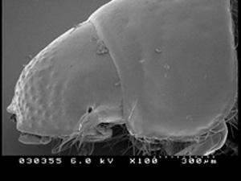 |  | 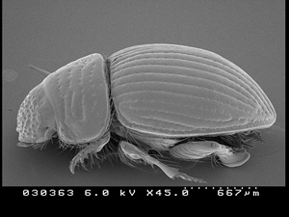
Figure 25. Geopsammodius hydropicus. |  | Figure 26. Geopsammodius morrisi.

13(11). All elytral intervals ridged to costate (Fig. 27). Pronotum with 3 more or less distinct, flat, vestigial transverse ridges, with equal number of transverse furrows, distinct vestige of midline furrow present …………………… Afrodiasticus Pittino and Mariani
13'. All elytral intervals weekly convex to flat, never ridged to costate (Fig. 28). Pronotum with no transverse ridges, with at most 2 incomplete transverse furrows, vestige of midline furrow present ……………………………………………………. 14
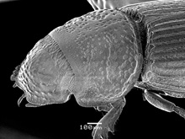 |  | 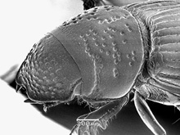
Figure 27. Afrodiastictus mimicus. |  | Figure 28. Platytomus micros.

14(13). Metatarsus elongate, at least as long as tibia; first tarsomere subequal in length to long spur (Fig. 29), cylindrical, slightly widened apically ………. Pleurophorus Mulsant
14'. Metatarsus weakly to strongly shortened, visibly shorter than tibia; first tarsomere shorter than long spur (Fig. 30), weakly to visibly widened at apex and slightly asymmetrical ……………………………………………………….. Platytomus Mulsant

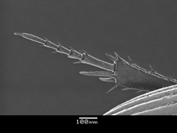 |  | 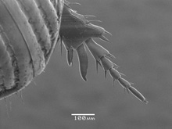
Figure 29. Pleurophorus caesus. |  | Figure 30. Platytomus micros.

