Key to genera of New World Odontolochini (Scarabaeidae: Aphodiinae)

1. Anterior clypeal margin with medial series of small teeth, appearing serrate (Fig. 1)
………………………………………………………………… Saprositellus Balthasar
1'. Anterior clypeal margin entire, lacking teeth (Fig. 2) …………………………… 2

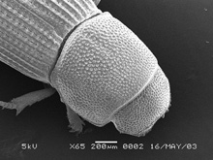 |  | 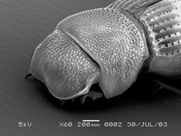
Figure 1. Saprositellus ariquemes. |  | Figure 2. Saprolonchus tambopatae.

2(1). Pronotum with coarse punctures restricted to broad transverse depression along basal third, anterior 2/3 swollen and finely punctate (Fig. 3) …….. Stebnickiella Skelley
2'. Pronotum with punctures evenly distributed, base lacking broad transverse depression
……………………………………………………………………………………………. 3

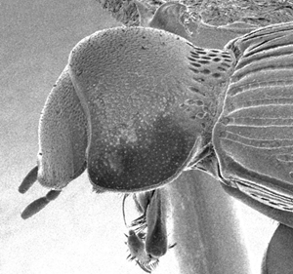
Figure 3. Stebnickella zosterixys.

3(2). Body elongate, surface argillaceous; head with punctures evenly distributed, obscured by argillaceous coating (Fig. 4); pronotum with 2 medial longitudinal ridges; alternate elytral intervals weakly carinate ………………………….. Amerilochus Skelley
3'. Body stout, surface not argillaceous, can be somewhat dulled (alutaceous)or glossy; head with band of large punctures at base, extremely fine punctures anteriorly (Fig. 2); pronotum evenly convex, lacking longitudinal ridges; elytral intervals similarly developed ……………………………………… Saprolochus Stebnicka and Galante

 |  | 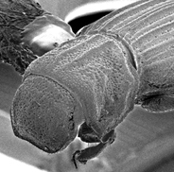
Figure 2. Saprolonchus tambopatae. |  | Figure 4. Amerilochus cinereus.

