Key to genera of New World Aphodiini (Scarabaeidae: Aphodiinae)

With insight provided in the key by G. Dellacasa et al. (2001) and a study of many New World taxa, this key was modified from Gordon and Skelley (2007) to include all presently recognized New World genus-level taxa. (as of summer 2007).

1. Scutellum large, triangularly elongate, 1/5 to 1/3 as long as elytron (Fig. 1) ……… 2
1'. Scutellum small, triangular to pentagonal, l/6 or less length of elytron (Fig. 2) …... 7

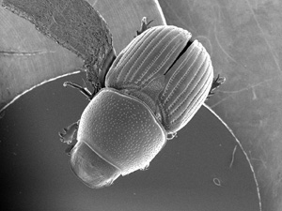 |  | 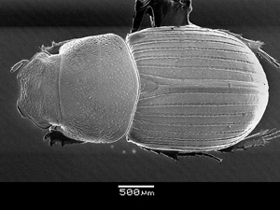
Figure 1. Otophorus haemorrhoidalis. |  | Figure 2. Oscarinus odocoilis.

2(1). Metatibial apex fringed with distinctly unequal spinules, mixed short and long. Elytral intervals often dulled ………………………………………………………….. 3
2'. Metatibial apex fringed with short spinules of equal length. Elytral intervals shiny
………………………………………………………………………………………….. 5

3(2). Frontal suture lacking tubercles. Head and pronotum with punctures widely separated and unevenly distributed (Fig. 5). Elytron shiny or dull. Elytral humerus with fine or widely spaced moderate punctures …………………………………………….. 4
3'. Frontal suture with median tubercle, often weak. Head and pronotum evenly covered with punctures separated by 1-2 diameters (Fig. 6). Elytron alutaceous. Elytral humerus with coarse, narrowly separated punctures ………………………. Colobopterus Mulsant

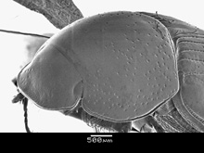 |  | 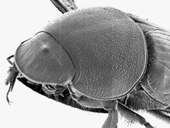

4(3). Superior metatibial spur shorter than basal metatarsal segment. Male with protibial spur and basal metatarsal segment unmodified. South America ……………………………………………………………..… Neodiapterna G. Dellacasa
4'. Superior metatibial spur longer than basal tarsal segment. Male with protibial spur and basal metatarsal segment greatly modified (Fig. 7-8). North America …. Diapterna Horn

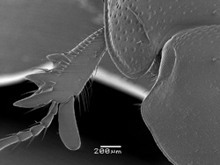 |  | 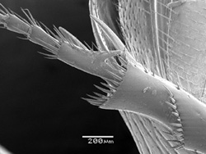
Figure 7. Diapterna pinguella. |  | Figure 8. Diapterna pinguella.

5(2). Body large, longer than 10 mm. Scutellum weakly punctured near base, surface nearly impunctate (Fig. 9) …………………………………………… Teuchestes Mulsant
5'. Body less than 8 mm long. Scutellum coarsely punctured on surface (Fig. 10) …….. 6

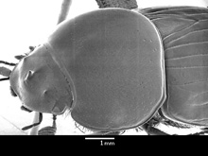 |  | 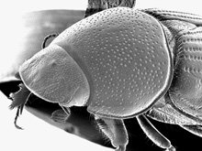
Figure 9. Teuchestes fossor. |  | Figure 10. Otophorus haemorrhoidalis.

6(5). Pronotum with mixed fine and coarse punctures evenly distributed, separated by 2-3 diameters (Fig. 11). Elytron with red apex. North America and Mexico
………………………………………………………………………. Otophorus Mulsant
6'. Pronotum with fine and very coarse punctures, coarse punctures unevenly distributed, widely scattered, separated by 3â€‘8 diameters (Fig. 12). Elytron unicolored, lacking red apex. Northeastern North America ……………………………….… Eupleurus Mulsant
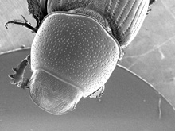 |  | 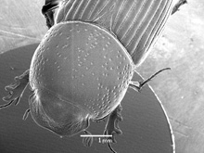
Figure 11. Otophorus haemorrhoidalis. |  | Figure 12. Eupleurus subterraneus.

7(1). All elytral intervals distinctly carinate on disc OR elytra with distinct humeral tooth, often both (Fig. 13) …………………………………………………………………….. 8
7'. Elytral intervals variously modified, never carinate (except Xenoheptaulacus which is carinate on alternate intervals). Elytral humerus lacking tooth ………………………. 26
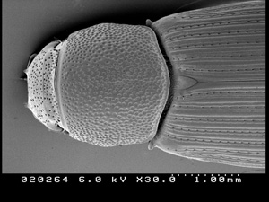
Figure 13. Dialytes ulkei.

8(7). Dorsal surface of protibia distinctly, densely punctured (Fig. 14) ………………… 9
8'. Dorsal surface of protibia impunctate ………………………………………………. 12
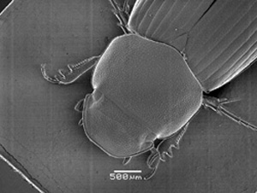
Figure 14. Gonaphodiellus hoffmani, protibia.

9(8). Elytral intervals and striae finely carinate. Brazil (?) …… Pleuraphodius Schmidt
9'. Elytral intervals and striae not finely carinate. Mexico to South America …………. 10

10(9). Elytral surface distinctly setose. Brazil (?) …… Trichaphodius Schimidt (in part)
10'. Elytral surface glabrous. Mexico to South America ……………………………… 11

11(10). Head and pronotal disc glossy, impunctate (Fig. 15). Pronotum constricted laterally. Mexico ……………………………… Imelda Dellacasa, Gordon and Dellacasa
11'. Head and pronotal disc distinctly punctured, often dull (Fig. 16). Pronotum emarginate at base, not constricted laterally. Mexico to South America
………………………………………………………………….. Gonaphodiellus Schmdit

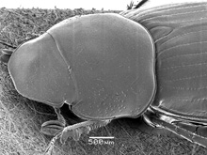 |  | 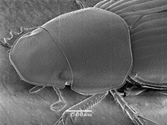
Figure 15. Imelda constricticollis. |  | Figure 16. Gonaphodiellus hoffmani.

12(8). Protibia with apical tooth close to tarsal insertion, projecting forward with tarsus (Fig. 17) ……………………………………………………………………………… 13
12'. Protibia with apical tooth removed from tarsal insertion and projecting away from tarsus (Fig. 18) ………………………………………………………………………. 14

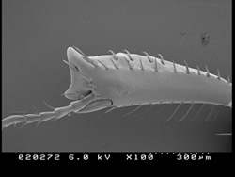 |  | 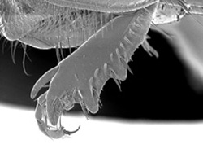
Figure 17. Dialytes ulkei. |  | Figure 18. Calamosternus granarius, male

13(12). Protibia slender, spur lacking (Fig. 19). Elytra distinctly bicolored. Chile
………………………………………………………………………. Acanthaphodius Schmidt
13'. Protibia broad, spur distinct (Fig. 20). Elytra unicolor, dark. Eastern North America
………………………………………………………………………………….. Dialytes Harold

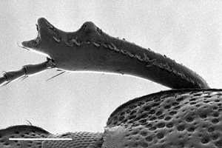 |  | 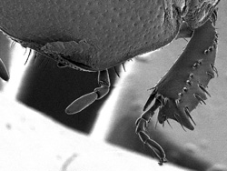
Figure 19. Acanthaphodius bruchi, female. |  | Figure 20. Dialytes striatulus.

14(12). Elytron carinate (Fig. 21-22) ……………………………………………… 15
14'. Elytron not carinate, intervals flat, convex or possibly tectiform, narrowly raised in middle (Fig. 23) ……………………………………………………………………. 16

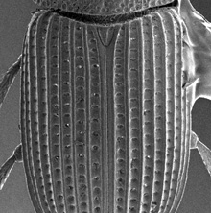 | 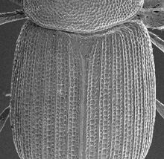 | 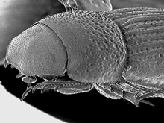
Figure 21. Oxyomus sylvestris. | Figure 22. Strigodius robinsoni. | Figure 23. Dialytodius decipiens.

15(14). Elytral striae with punctures as wide as carinate intervals (Fig. 24). Clypeal margin rounded. North America and Mexico …………………….…. Oxyomus Dejean
15'. Elytral striae with punctures much narrower than interval (Fig. 25); intervals with row of punctures on each side of middle carina same size as strial punctures, giving each interval a tri-carinate appearance obscuring striae. Clypeal margin distinctly dentate. Eastern North America …………………………….….. Strigodius Gordon and Skelley

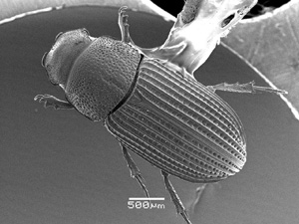 |  | 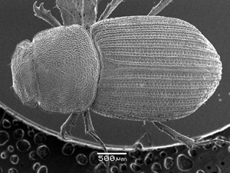
Figure 24. Oxyomus sylvestris. |  | Figure 25. Strigodius robinsoni.

16(14). Elytral intervals strongly and irregularly punctured, with scattered setae, dull appearing (Fig. 26). Pronotal base usually lacking marginal groove. Southwestern US and Mexico ………………………………………………………………………………… 17
16'. Elytral intervals weakly punctured or punctures in two regular rows, rarely with setae, most with glossy intervals (Fig. 27). Pronotal base rarely lacking marginal groove. Widespread ……………………………………………………………………………. 19

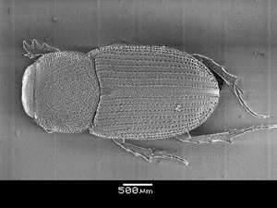 |  | 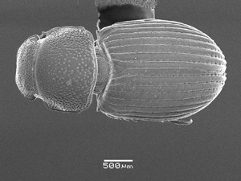
Figure 26. Neotrichonotulus inurbanus. |  | Figure 27. Dialytellus dialytoides.

17(16). Elytra short, laterally curved, not parallel-sided. Metatarsus distinctly pubescent; apical segments about as wide as long. Mexico ……………………………………………….… Jalisco Dellacasa, Gordon and Dellacasa
17'. Elytra normal length, parallel-sided laterally. Metatarsus not pubescent, with few scattered setae; apical segments distinctly longer than wide. Mexico, southern Arizona
………..…………………………………………………………………………….. 18

18(17). Anterior angles of pronotum not explanate (Fig. 28). Mexico, southern Arizona
…………………………………….. Neotrichonotulus Dellacasa, Gordon and Dellacasa
18'. Anterior angles of pronotum narrowly explanate (Fig. 29). Mexico Trichonotuloides Balthasar (in part)

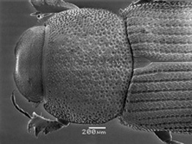 |  | 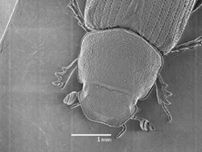
Figure 28. Neotrichonotulus inurbanus. |  | Figure 29. Trichonotuloides glyptus.

19(16). Pronotum with base narrower than apex and lacking distinct posterior angles (Fig. 30), or base distinctly sinuate (Fig. 31). Body of most longer than 7 mm, some western members 5 mm. North America ……………………….. Stenotothorax Schmidt (in part)
19'. Pronotum with distinct posterior angles, lateral base not narrower than apex, base lobed or straight but not sinuate (Fig. 32). Body length usually less than 5 mm, except rare individuals ……………………………………………………………………… 20

Figure 21. Oxyomus sylvestris. | Figure 22. Strigodius robinsoni. | Figure 23. Dialytodius decipiens.

20(19). Elytra distinctly mottled black and yellowish. Body wedge-shaped in lateral view (Fig. 33), head and pronotum somewhat flattened, elytra with greatest height near apical third. Mexico ………………… Pseudogonaphodiellus Dellacasa, Gordon and Dellacasa
20'. Elytra not distinctly mottled, some bicolored. Body not flattened (Fig. 34), approximately same height as elytra ………………………………………………… 21

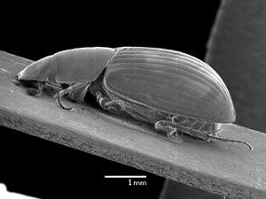 |  | 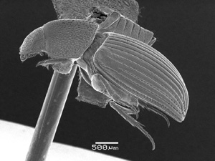
Figure 21. Pseudogonaphodiellus zdzslawae, male. |  | Figure 22. Dialytellus dialytoides.

21(20). Clypeal surface with long, erect setae (Fig. 35). Clypeal apex with nearly spiniform tooth on each side of middle. Southwestern North America
……………………………………………………………. Luxolinus Gordon and Skelley
21'. Clypeal surface without setae. Clypeal apex not toothed, possibly angulate (tooth short, broadly triangular) ……………………………………………………………… 22

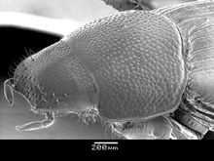
Figure35. Luxolinus luxatus

22(21). Dorsal surface strongly dulled, with sculpture composed of very fine, polygonal meshes (Fig. 36). Elytral intervals flat. Northwestern North America
………………………………………………… Caligodorus Gordon and Skelley (in part)
22'. Dorsal surface shiny, if dull, then elytral intervals distinctly convex (Fig. 37) …23

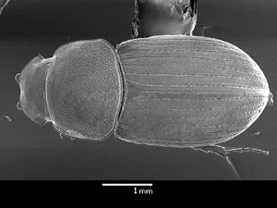 |  | 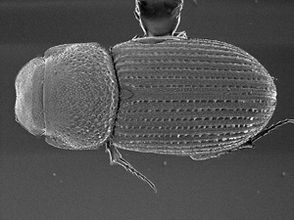
Figure 36. Caligodorus opacus. |  | Figure 37. Dialyoidius decipiens.

23(22). Elytral interval 10 raised on posterior half, becoming the lateral margin (Fig. 38). All intervals complete to apical margin. Appalachian region of North America
……………………………………………………………………… Hornietus Stebnicka
23'. Elytral interval 10 not notably raised, not forming lateral margin (Fig. 39). Some intervals fused before attaining margin ………………………………………………. 24

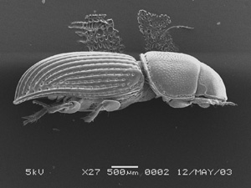
Figure 38. Hornietus ventralis. |  | Figure 39. Dialytellus dialytoides.

24(23). Posterior pronotal angles laterally emarginate (Fig. 40). Eastern North America
………………………………………………………………………… Dialytellus Brown
24'. Posterior angles not emarginate, base of pronotum rectangular (Fig. 41). North Dakota and Nevada to British Columbia and California ……………………………… 25

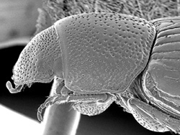 |  | 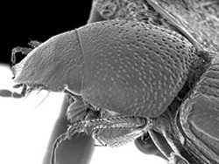
Figure 40. Dialytellus dialytoides. |  | Figure 41. Dialytodius carr.

25(24). Elytral color yellow or yellowish brown. Elytral intervals weakly convex, nearly flat (Fig. 42). Elytra narrow basally, distinctly widened on apical declivity. California
………………………………………..………. Caligodorus Gordon and Skelley (in part)
25'. Elytral color brown or black. Elytral intervals distinctly convex to tectiform (Fig. 43). Elytra widest at middle or slightly wider on apical declivity. Northwestern North America …………………………………………… Dialytodius Gordon and Skelley

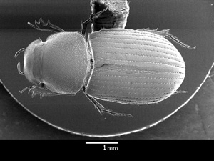 |  | 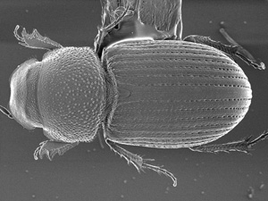
Figure 42. Calidodorus vandyke. |  | Figure 43. Dialytodius carr.

26(7). Clypeus with distinct, long, dense lateral fringe of setae, visible dorsally (Fig. 44). Clypeus angulate or toothed, if clypeus rounded, then pronotum and elytron also with dense, long setal fringe. Head lacking median frontal tubercle ……………………….. 27
26'. Clypeus at most with sparse fringe of setae, frontal lobe often fringed (Fig. 45). If clypeus angulate or toothed, then setal fringe lacking. Head with or without frontal tubercle ………………………………………………………………………………… 34

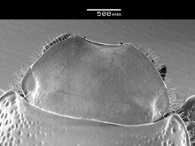 |  | 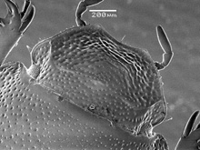
Figure 44. Dellacasiellus carpinterius. |  | Figure 43. Pardalosus sayi.

27(26). Pronotum distinctly narrowed to base, posterior angles absent (Fig. 46)
……………………………………..…………………….. Stenotothorax Schmidt (in part)
27'. Pronotum not narrowed toward base, or with posterior angles present, often weakly indicated (Fig. 47); if posterior angles weak, then apical tooth of protibia larger than medial tooth and projecting at right angle to axis of tibia (Cinacanthus) …………….. 28

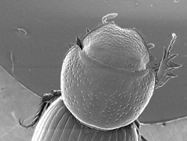 |  | 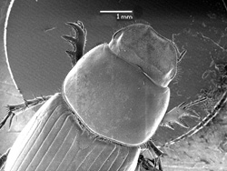
Figure 46. Stenotothorax nevadensis. |  | Figure 47. Dellacasiellus laevigatus.

28(27). Head nearly semicircular (Fig. 48). Clypeus lacking teeth and median emargination. Southwestern North America
………………………..……. Cephalocyclus Dellacasa, Gordon and Dellacasa (in part)
28'. Head not semicircular. Clypeus with teeth or distinct median emargination … 29

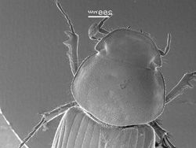
Figure 48. Cephalocyclus hogei.

29(28). Body robust, reddish. Elytral fold with deep setose groove at base (Fig. 49), lacking only in D. laevigatus from southeastern US. Base of elytral striae 3â€‘5 usually widened and sharply margined, interval 4 usually narrowed at base (Fig. 50). Clypeal apex denticulate or angulate. North America and Mexico
…………………………………………………….. Dellacasiellus Gordon and Skelley
29'. Body color and shape variable. Elytral fold lacking deep setose groove at base. Base of elytral striae 3â€‘5 not widened, interval 4 not narrowed at base. Clypeus variable, often distinctly toothed …………………………………..…………………………. 30

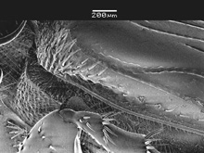 |  | 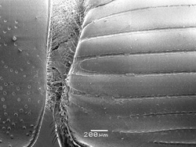
Figure 49. Dellacasiellus concavus. |  | Figure 50. Dellacasiellus concavus.

30(29). Pronotal base S-shaped with angulation each side of middle (Fig. 51), with or without marginal line at base. Southwestern North America, Mexico
………………………………………………………………….... Coelotrachelus Schmidt
30'. Pronotal base weakly sinuate, lacking angulation, with complete marginal line at base ………………………………………………………………………………………….. 31

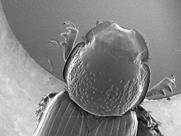
Figure 51. Coelotrachelus rudis.

31(30). Clypeal teeth spiniform. Protibia with apical tooth large and projecting at right angle to axis of tibia (Fig. 52). Protibial spur inserted opposite second protibial tooth (Fig. 53). Male protibial spur extremely reduced in size, concealed beneath tibial border; female protibial spur small, visible in dorsal view. Body uniformly red. Great Plains and western North America …………………………………………… Cinacanthus Schmidt
31'. Clypeal teeth at most strongly angulate, rarely appearing spiniform. Protibia with apical tooth not enlarged, projecting more anteriorly. Protibial spurs large, variably set, usually inserted closer to apical tooth, visible dorsally in both sexes. Body color variable
…………………………………………………………………………………………. 32

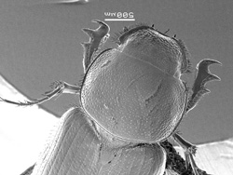 |  | 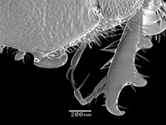
Figure 52. Cinacanthus militaris. |  | Figure 53. Cinacanthus militaris.
32(31). Small, length nearly 3 mm. Elytron yellowish with distinct black markings. California and Mexico …………………….. Rugaphodius Gordon and Skelley (in part)
32'. Larger, length greater than 5 mm. Elytron variable, lacking distinct black markings. Widespread …………………………………………………………………………… 33

33(32). Body black dorsally. Clypeus with two broadly placed, angulate teeth (Fig. 54), lacking modified margin between teeth. Epipharynx with corypha short, with cluster of
4-6 apical spines. Head lacking distinct lateral notch at frontal suture. Pronotum and elytra lacking distinct lateral fringe of long setae. North America and Mexico
………………………………………………………… Pseudagolius Schmidt (in part)
33'. Body black, reddish brown, or pale dorsally. Clypeus with 4, 2 or no teeth, teeth often narrowly spaced (Fig. 55); when present clypeal teeth varying from nearly spiniform to broadly angulate, some with margin between teeth triangularly modified. Epipharynx with corypha strongly projecting, peg-like, with 2 stout apical spines. Head on some with distinct notch laterally at frontal suture. Pronotum and elytra on some with distinct lateral fringe of long setae. Western North America
……………………………………………………….. Tetraclipeoides Schmidt (in part)

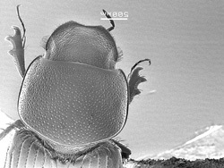 |  | 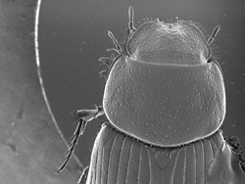
Figure 54. Pseudagolius bicolor. |  | Figure 55. Tetraclipeoides dentigerulus.
34(26). Pronotum distinctly narrowed from apex to base (Fig. 56), posterior angles absent. North America ………………………………. Stenotothorax Schmidt (in part)
34'. Pronotum not narrowed toward base, or with posterior angles present; or from elsewhere. Widespread ……………………………………………………………… 35
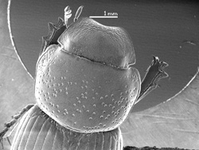
Figure 56. Stenothorax lanei.
35(34). Dorsal surface of protibia distinctly, densely punctured (Fig. 57). Clypeal apex lacking teeth, rounded on each side of middle ………………………………….……. 36
35'. Dorsal surface of protibia impunctate (Fig. 58). Clypeal apex with teeth or not … 40

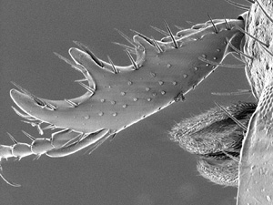 |  | 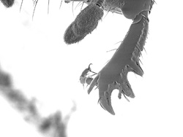
Figure 57. Blackburneus fordi. |  | Figure 58. Oscarinus lodingi.

36(35). Alternate elytral intervals distinctly carinate, other intervals flat. Panama to northern South America ………………………………..…… Xenoheptaulacus Hinton
36'. Elytral intervals all equally convex, none carinate. Widespread ……………… 37

37(36). Apical tibial fringe of setae long and unequal in length (Fig. 59). Elytra variably setose laterally and dorsally; glabrous, with setal patch near lateral apex, or entirely setose. Head never with median tubercle …………………………..………………. 38
37'. Apical tibial fringe of setae short and equal in length (Fig. 60). Elytra never setose. Head of males with distinct median tubercle, female tubercle weak ………………. 39

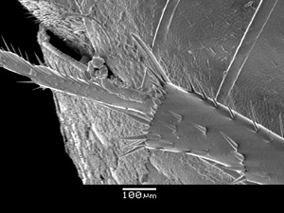 |  | 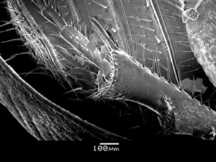
Figure 59. Blackburneus sterocorosus. |  | Figure 60. Haroldiellus sallei.

38(37). Elytra variably setose, setae often limited to lateral apex. If elytra dorsally setose, then from North America. Widespread …………………………. Blackburneus Schmidt
38'. Elytral surface entirely setose. Brazil (?) ………….. Trichaphodius Schmidt (in part)

39(37). Elytral striae coarsely punctured, intervals strongly convex. Pronotal base with fine marginal line (Fig. 61). Body robust, dark reddish brown. Caribbean and Central America to southern Texas ………………… Haroldiellus Gordon and Skelley (in part)
39'. Elytral striae finely punctured, intervals weakly convex. Pronotal base lacking marginal line (Fig. 62). Body weakly robust, brown, with weak pattern on apex of elytra. South America ………………………………………………… Trichaphodiellus Schmidt

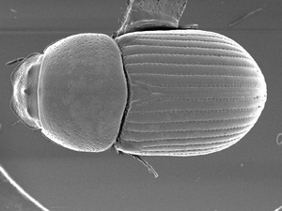 |  | 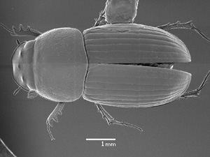
Figure 61. Haroldiellus sallei. |  | Figure 62. Trichaphodiellus brasiliensis.

40(35). Clypeal apex broadly semicircular (Fig. 63). Frontal lobe pronounced, triangular, projecting far beyond eye. Head black. Lateral pronotal margin with wide, distinctly raised border. Eastern North America …………………………..….. Acrossus Mulsant
40'. Clypeal apex usually emarginate medially (Fig. 64); if semicircular, then narrowed, or head pale, not black, or frontal lobe not pronounced. If frontal lobe triangular, then not projecting much beyond eye. Lateral pronotal margin, if present, narrow, slightly raised. Widespread …………………………………………………………………………… 41
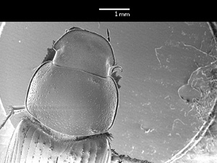 |  | 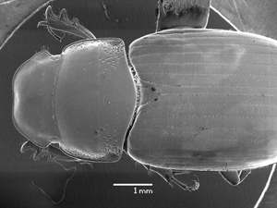
Figure 63. Acrossus rubripennis. |  | Figure 64. Cryptoscatomaseter haldemani.

41(40). Elytral disc distinctly and nearly entirely setose (Fig. 66); if setae indistinct, then surface strongly roughened and dulled. US and Canada ……..……………………… 42
41'. Elytral disc lacking setae, or setae visible only on declivity and lateral margin; surface usually shiny, occasionally shiny between dense, coarse punctures. Widespread
………………………………………………………………………………………… 47

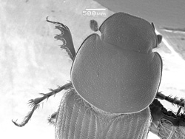
Figure 66.

42(41). Clypeal apex nearly truncate, lateral angles broadly rounded (Fig. 66); clypeal surface shiny, glabrous, punctures well separated. Pronotum black, elytron yellow and pale brown. North and Central America ……………….. Melinopterus Mulsant (in part)
42'. Clypeal apex emarginate, lateral angles broadly rounded to toothed (Fig. 67); clypeal surface usually densely punctate or granulate, setiferous or glabrous. Pronotum and elytron usually similar in color, black to dark brown ……………………………….. 43

 |  | 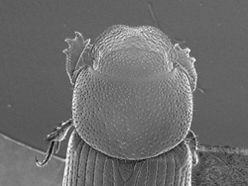
Figure 66. Melinopterus femoralis. |  | Figure 67. Setodius diogenes.

43(42). Elytral disc yellowish, black laterally and apically. northwestern North America
……………………………………………………. Setodius Gordon and Skelley (in part)
43'. Elytral disc color uniform or with vague darker markings on disc. Arizona or eastern US …………………………………………………………………………………….. 44

44(43). Clypeal surface granulate (Fig. 68). Body dark brown. Southern Great Plains and southeastern North America …………… Scabrostomus Gordon and Skelley (in part)
44'. Clypeal surface smooth, punctures distinct (Fig. 69). Body usually black ……... 45

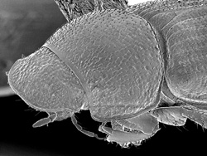 |  | 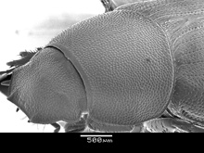
Figure 68. Scabrostomus baileyi. |  | Figure 67. Lechorodius lutulentus.

45(44). Clypeal apex dentate (Fig. 70). Eastern North America
……………………………………………….. Lechorodius Gordon and Skelley (in part)
45'. Clypeal apex rounded ………………………………………………………….… 46

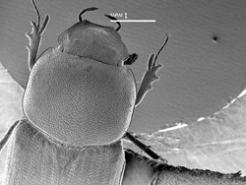
Figure 70. Lechorodius lutulentus.

46(45). Head coarsely punctate, punctures impressed. Pronotal base distinctly margined at middle (Fig. 71). Southeastern North America ………. Irrasinus Gordon and Skelley
46'. Head finely punctate, punctures not impressed. Pronotal base lacking marginal line at middle (Fig. 72). Northeastern North America …………………….. Trichonotulus Bedel

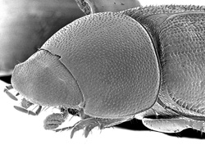 |  | 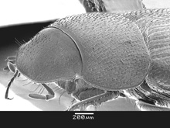
Figure 71. Irrasinus stupidus. |  | Figure 72. Trichonotulus scrofa.

47(41). Meso- and metatibial apices fringed with short (Fig. 73), more or less equal spinules ………………………………………………………………………………. 48
47'. Meso- and metatibial apices fringed with distinctly long and unequal spinules (Fig. 74), usually alternating long and short; apical spinules frequently worn or broken, if so, consider those on the transverse median carina of tibia ……………………………… 72

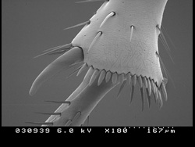 |  | 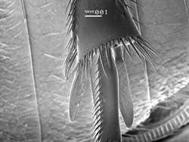
Figure 73. Agoliinus anthracus. |  | Figure 74. Cryptoscatomaseter haldemani.

48(47). Pronotum lacking basal marginal line (Fig. 75). Scutellum usually pentagonal, lateral margins parallel or convergent toward base ………………………………..… 49
48'. Pronotum with basal marginal line (Fig. 76). Scutellum triangular or pentagonal, lateral margins parallel or diverging toward base …………………………………… 51

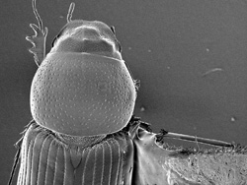 |  | 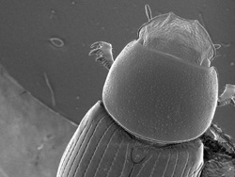
Figure 75. Nialaphodius nigrita. |  | Figure 76. Oscarinus windsori.

49(48). Elytral striae deep apically, none shortened or joined preapically, all reaching apical margin (Fig. 77). Mexico …………………………………. Pharaphodius Reitter
49'. Elytral striae deep or not, striae 7-10 variably shortened or joined preapically (Fig. 78). Widespread ………………………………………………………………….…. 50

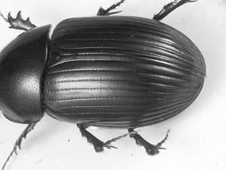 |  | 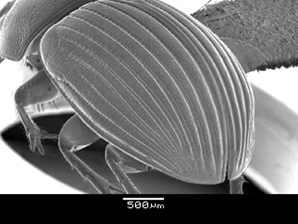
Figure 77. Pharaphodius oleosus. |  | Figure 78. Oscarinus crassulus.

50(49). Elytron yellow, often with a more or less distinct brownish discal spot (Fig. 79). Widespread …………………………………………………. Labarrus Mulsant and Rey
50'. Elytron brown, reddish brown, or nearly black, without maculation (Fig. 80). Southeastern North America ……………………………………….. Nialaphodius Kolbe

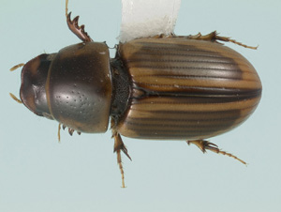 |  | 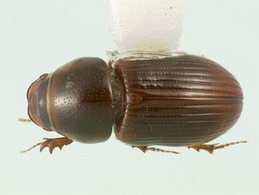
Figure 79. Labarrus pseudolividus. |  | Figure 80. Nialaphodius nigrita.

51(48). Scutellum parallel or convergent toward base, frequently depressed below elytral surface (Fig. 81). Pronotal punctures widely scattered. Frontal tubercle present. Mexico and North America ………………………………………… Calamosternus Motschulsky
51'. Scutellum parallel or diverging toward base, usually triangular, not depressed below elytral surface (Fig. 82). Pronotal punctures evenly distributed, usually closely spaced. Frontal tubercle present or not ……………………………………………………….. 52

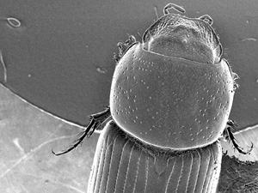 |  | 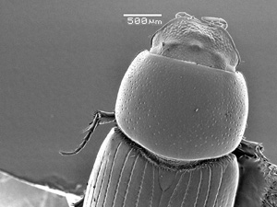
Figure 81. Calamosternus granarius. |  | Figure 82. Oscarinus rusicola.

52(51). Clypeus distinctly toothed or sharply angulate on each side (Fig. 83) ……… 53
52'. Clypeus rounded or weakly angulate on each side of middle (Fig. 84) ……….. 57

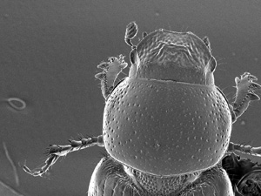 |  | 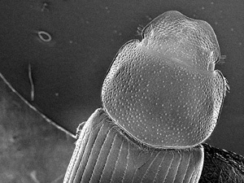
Figure 83. Mendidius aculeatus. |  | Figure 84. Pardalosus neodistinctus.

53(52). Body robust, entirely black. Lacking transverse clypeal ridge. Male parameres dorsoventrally flattened, lacking membranous appendages. Prairie states, southwestern and eastern North America, and Mexico ….… Oscarinus Gordon and Skelley (in part)
53'. Body more elongate, not robust, bicolored or pale, if black then with transverse clypeal ridge. Male parameres dorsoventrally flattened or not, often with membranous appendages. Northwestern and western North America ………………………… 54

54(53). Clypeal apex quadridentate (Fig. 85). California and Oregon
…………………………………………………... Maculaphodius Gordon and Skelley
54'. Clypeal apex bidentate ………………………………………………………... 55

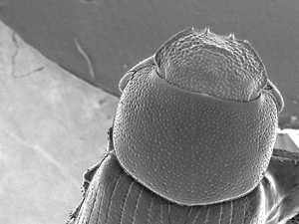
Figure 85. Maculaphodius conspersus.

55(54). Small, length nearly 3 mm. Clypeus with angulation laterad of apical tooth (Fig. 86). California, Mexico ……………………. Rugaphodius Gordon and Skelley (in part)
55'. Larger, length 4 mm or more. Clypeus without angulation laterad of apical tooth
………………………………………………………………………………………. 56

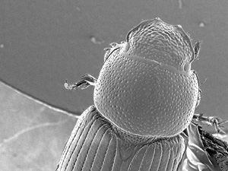
Figure 86. Rugaphodius rugatus.

56(55). Body entirely pale brown. Male parameres lacking membranous lobes. Southwestern North America ……………………………………….. Mendidius Harold
56'. Body black, elytron red or with color pattern, rarely black. Male parameres with dorsal membranous appendage. Widespread, but not southeastern US
……………………………………………………………….. Agoliinus Schmidt (in part)

57(52). Clypeal apex weakly to distinctly emarginate medially (Fig. 87). Body 5 mm or longer, reddish brown or yellowish brown. Pronotum usually with fringe of long setae (lacking in B. obtusus). Western North America, southern South America ………… 58
57'. Clypeal apex distinctly emarginate medially (Fig. 88). Body length variable, color variably brown to dark brown. Pronotum usually lacking fringe of setae. Widespread
…………………………………………………………………………………….… 59

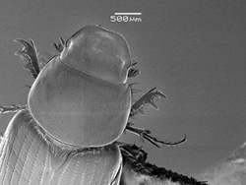 |  | 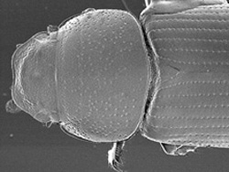
Figure 87. Ballucus bruneaui. |  | Figure 88. Pardalosus pardalis.

58(57). From Western North America ………... Ballucus Gordon and Skelley (in part)
58'. From Peru, Chile, Argentina ……………………………... Orodaliscoides Schmidt

59(57). Pronotum wider than long, rectangular, weakly flattened (Fig. 89). Head and pronotal sides uniformly, densely punctate. Body color uniformly pale reddish brown. Southwestern North America ………………..….. Schaefferellus Gordon and Skelley
59'. Pronotum not rectangular, more robust (Fig. 90). Head and pronotal sides usually not uniformly, densely punctate. Body color usually dark, often with contrasting pattern …60

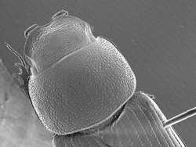 |  | 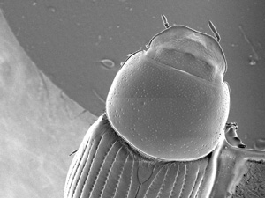
Figure 89. Schaefferellus arizonenis. |  | Figure 90. Oscarinus floridanus.

60(59). Pronotum, and usually elytron, fringed with long setae (Fig. 91). Body length 4 mm or less. Northwestern North America ……… Setodius Gordon and Skelley (in part)
60'. Pronotum and elytron not distinctly fringed with long setae. Body length variable, usually longer than 4 mm …………………………………………………………… 61

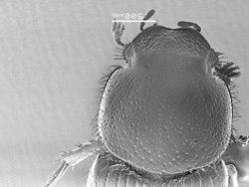
Figure 91. Setodius edmontonus.

61(60). Body length 4 mm or less. Each elytron yellow with 2 large black marks and a dark sutural margin (Fig. 92). Southwestern North America
………………………………………………… Pardalosus Gordon and Skelley (in part)
61'. Body length variable, usually more than 4 mm. Elytron black or red, frequently with numerous small black marks or large pale spots ……………………………………. 62

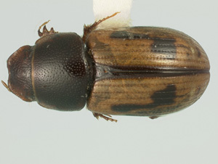
Figure 92. Pardalosus pumilio.

62(61). Body black, entire elytron and anterior pronotal angles red. Head surface shiny, frontal suture with distinct median tubercle, usually trituberculate (Fig. 93). Male pronotum with distinct median apical depression. Body robust, length 6 mm or more. North America and Mexico …………………………………………… Aphodius Illiger
62'. Body and elytra usually same color; if notably contrasting, then elytron with distinct markings. Head surface variable, frontal suture often lacking median tubercle. Pronotum lacking depression at median apical margin. Body robust or not, usually somewhat flattened, length variable ……………………………………………………………. 63

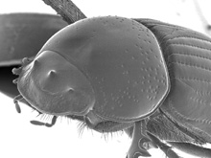
Figure 92. Aphodius fimetarius.

63(62). Body entirely red, robust, not at all flattened (Fig. 94). Lateral pronotal margin straight from angle to angle in lateral view (Fig. 95). Nebraska and Texas
…………………………………………………. Oscarinus Gordon and Skelley (in part)
63'. Body mostly black, not entirely red, robust or not (often weakly flattened). Lateral pronotal margin curved in lateral view, most notably near anterior or posterior angles (Fig. 96) ……………………………………………………………………………… 64

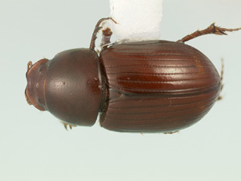 |  | 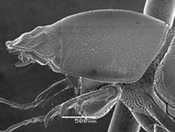
Figure 94. Oscarinus mataganae. |  | Figure 95. Oscarinus mataganae.
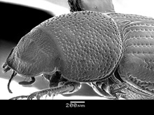
Figure 96. Planolinoides neotomae.

64(63). Clypeal surface with transverse ridge (Fig. 97) (indistinct in P. borealis). Elytron lacking color pattern. Body length less than 5 mm. Male parameres distinctly shortened, nearly as long as wide. Western and northern North America
………………………………………………. Planolinoides Dellacasa and Dellacasa
64'. Clypeus without transverse ridge (if transverse ridge present, body entirely red). Elytron with or without color pattern. Body length variable. Male parameres distinctly longer than wide. Widespread ………………………………………………………… 65

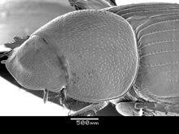
Figure 97. Planolinoides pectoralis.

65(64). Body robust; color dark brown, elytral intervals usually paler on declivity. Elytral striae with coarse punctures, intervals strongly convex ………………………………. 66
65'. Body usually not robust, elongate, if robust then color uniformly black. Elytral striae with moderate punctures, not strongly convex; widespread ………………………….. 67

66(65). Lateral elytral intervals distinctly punctate (Fig. 98). Head lacking distinct tubercle in both sexes. Mexico ……………… ‘Agrilinus’ (s.l.) Mulsant and Rey (in part)
66'. Lateral elytral intervals finely punctate (Fig. 99). Head with distinct median tubercle in male, weak tubercle in female. Caribbean and Central America to southern Texas
………………………………………….... Haroldiellus Gordon and Skelley (in part)

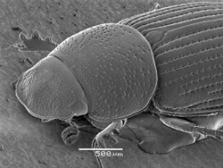 |  | 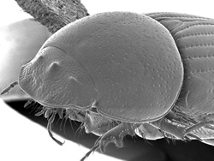
Figure 98. Agrilinus ornatus. |  | Figure 99. Haroldiellus sallei, male

67(65). Pronotum dark, elytra variously spotted with yellowish marks (Fig. 100-101). Head lacking median tubercle. Male paramere distinctly half length of basal piece. Mexico ………………………………..….. ‘Agrilinus’ (s.l.) Mulsant and Rey (in part)
67'. Color variable, elytra entirely dark, usually not spotted with yellowish marks, often with large color patches or spotted in black. Head frequently with median tubercle. Male paramere nearly equal length of basal piece. Mexico and North America …………… 68

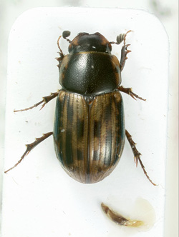 |  | 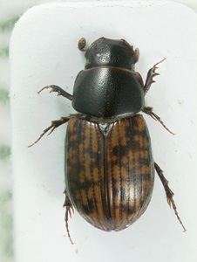
Figure 100. Agrilinus azteca. |  | Figure 101. Agrilinus azteca, female

68(67). Clypeus broadly rounded on each side (Fig. 102). Frontal suture lacking median tubercle ……………………………………………………………………………….. 69
68'. Clypeus rounded or not (Fig. 103). Frontal suture usually with median tubercle …71

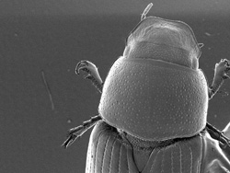 |  | 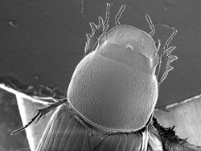
Figure 102. Planolinus tenellus. |  | Figure 103. Planolinellus vittatus, male
69(68). Elytral intervals with distinct punctures (Fig. 104), most notable laterally. Northern and western North America ………………………. Liothorax Motschulsky
69'. Elytral intervals lacking distinct punctures (Fig. 105). More widespread, boreal
…………………………………………………………………………………….. 70

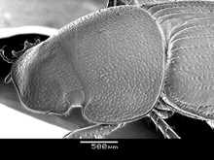 |  | 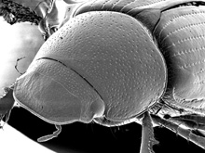
Figure 104. Liothoraxn alternatus. |  | Figure 105. Planolinus tenellus.

70(69). Metafemur normal, distinctly longer than wide …… Planolinus Mulsant and Rey
70'. Metafemur nearly quadrate, nearly as wide as long (Fig. 106)
………………………………………………………….... Merogyrus Gordon and Skelley

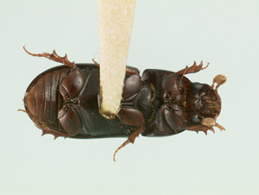
Figure 106. Merogyrus rotindiceps.

71(68). Length less than 5 mm. Clypeal surface dull and finely punctate (Fig. 107). Elytron black with variable sized red marks at humerus and apex, often nearly entirely red. Widespread ………………………………….. Planolinellus Dellacasa and Dellacasa

71'. Length variable, usually larger than 5 mm. Clypeal surface and punctation variable, shiny. Elytral color variable on larger specimens, smaller specimens entirely dark brown to black ………………………………………………………………………………… 98

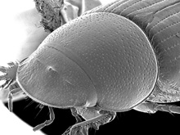
Figure 107. Planolinellus vittatus, male.

72(47). Elytra with distinct apical umbone (Fig. 108). Andean region of South America
…………………………………………………………………………………………. 73
72'. Elytra lacking distinct apical umbone (Fig. 109). Mexico and North America ……76

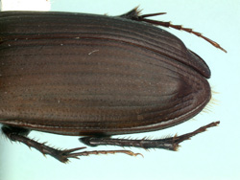 |  | 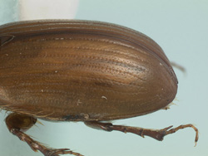
Figure 108. Pseudopodotenus fulviventris. |  | Figure 109. Orodaliscoides reflexus.

73(72). Apical pair of protibial teeth broadly joined (Fig. 110). Body pale brown. Chile
………………………………………………………………………. Symphodon Schmidt
73'. Apical pair of protibial teeth normal, widely separated. Body usually black, elytra occasionally pale. Andean region of South America ………………………………….. 74

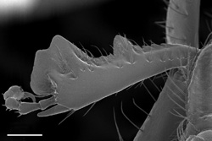
Figure 110. Symphodon anomalum.

74(73). Alternating elytral intevals moderately convex with weak pubescent tubercles. Chile …………………………………………………………….…… Podotenus Schmidt
74'. Alternating elytral intervals not alternately modified, or lacking pubescent tubercles. Andean region of South America ……………………………………………………… 75

75(74). Abdomen orange, contrasting against black body. Pronotal hind angles distinct, base strongly sinuate (Fig. 111). Male protibia distinctly bidentate, female distinctly tridentate. Chile, Argentina …………………………… Pseudopodotenus G. Dellacasa
75'. Abdomen and body dark, not contrasting. Pronotal hind angle rounded, base weakly sinuate (Fig. 112). Male and female protibia weakly tridentate. Chile, Argentina, Ecuador, Bolivia ………………………………………………….. Paranimbus Schmidt

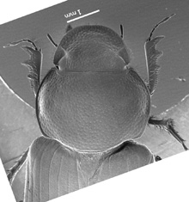 |  | 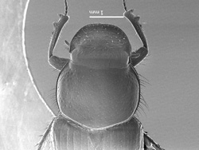
Figure 111. Pseudopodotenus fulviventris, female. |  | Figure 112. Paranimbus peruanus, male.

76(72). Pronotal base usually lacking marginal line at middle (Fig. 113), if fine line present (Fig. 114), then coarse pronotal punctures lacking on most of disc. Pronotum broad and explanate, often reflexed with lateral shelf, usually with depression near posterior angles …………………………………………………………………… 77
76'. Pronotal base with distinct marginal line (Fig. 115). Pronotum usually not broad or explanate; if pronotum explanate, then punctures of disc evenly distributed over surface
…………………………………………………………………………………….. 78

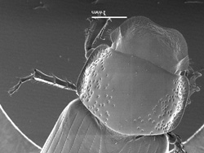 |  | 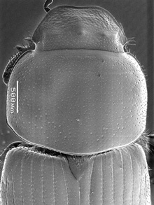
Figure 114. Cryptoscatomaseter brevicollis. |  | Figure 115. Chilothorax distinctus, male.

77(76). Clypeus, lateral pronotal margin and elytron with sparse lateral fringe of long setae (Fig. 116). Pronotal disc never with depression near posterior lateral angle. Mexico and southwestern North America
……………………………….. Cephalocyclus Dellacasa, Gordon and Dellacasa (in part)
77'. Lateral margin of elytron, pronotum, and clypeus lacking fringe of setae (Fig. 117). Pronotal disc often with depression near posterior lateral angle. Mexico to Canada
…………………………………………….….. Cryptoscatomaseter Gordon and Skelley

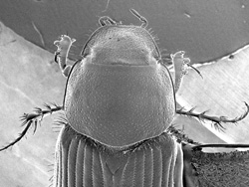 |  | 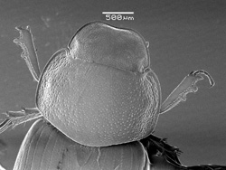
Figure 116. Cephalocyculs luteolus. |  | Figure 117. Cryptoscatomaseter ejectus.

78(76). Pronotum with lateral fringe of long setae easily visible in dorsal view (Fig. 118)
…………………………………………………………………………………………. 79
78'. Pronotum lacking lateral fringe of long setae, setae not visible in dorsal view (Fig. 119), or setal fringe short and dense (Fig. 120), appearing more uniform in length ….. 85

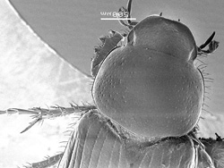 |  | 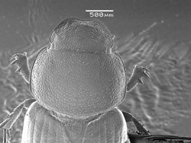
Figure 118. Flaviellus aggregatus. |  | Figure 119. Geomyphilus geronimo.
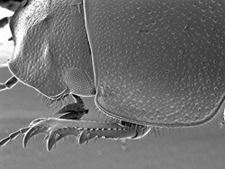
Figure 120. Agoliinus ashworthi.

79(78). Body and elytra dark brown to black, elytra occasionally with paler markings
……………………………………………………….……. Phaeaphodius Reitter (in part)
79'. Body and elytra pale, occasionally with black pronotal disc and elytral markings
…………………………………………………………………………………..…… 80

80(79). Pronotum black; elytron with distinct color pattern of black spots on yellow background (Fig. 121). North America …………… Chilothorax Motschulsky (in part)
80'. Pronotum usually not black, if black, then elytron lacking color pattern ………... 81

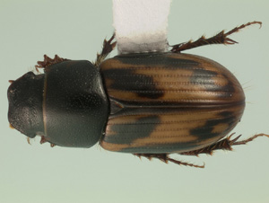
Figure 121. Chilothorax distinctus.

81(80). Head and body somewhat flattened (Fig. 122). Head surface smooth, finely punctate, lacking distinct tubercles or ridges ………………………………………… 82
81'. Head and body robust (Fig. 123-124), more Psammodius-like. Head surface usually coarsely punctate and rugose, usually with distinct tubercles or frontal ridge …83

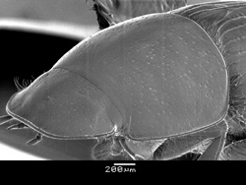 |  | 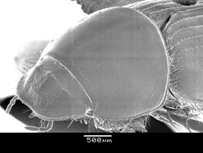
Figure 122. Flaviellus gordoni. |  | Figure 123. Ballucus barri.
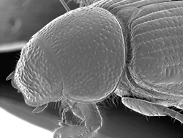
Figure 124. Xeropsamobeus mohavei.
82(81). Elytron setose laterally and on declivity, setae sometimes indistinct (Fig. 125). Male protibial spur long, projecting beyond anterior protibial tooth. Central and western North America and Mexico ………………………………. Drepanocanthoides Schmidt
82'. Elytron lacking setae laterally and on apical declivity. Male protibial spur short, not surpassing protibial apical tooth. Widespread ………..….. Flaviellus Gordon and Skelley

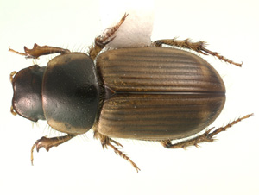
Figure 125. Drepanocanthoides walshi.

83(81). Clypeus smooth, shiny, broadly rounded each side of emargination (Fig. 126). Pronotal fringe dense. Body length 6 mm or more. Northwestern North America to Nebraska ……………………………………….. Ballucus Gordon and Skelley (in part)
83'. Clypeus usually rugose to granulate, rounded to distinctly toothed each side of emargination (Fig. 127). Pronotal fringe usually not dense. Body length 3-6 mm. Prairie states and southwestern North America and Mexico ……………………… 84

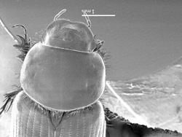 |  | 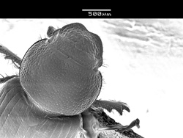
Figure 126. Ballucus barri. |  | Figure 127. Scabrostomus siccatus.

84(83). Metatibia with basal tarsomere distinctly shorter than superior spur (Fig. 128); and/or metatibia thickened, evenly widened to broad apex. Metatibial fringe with long spinules usually less than 2 times longer than short spinules. Pronotum dark or pale, elytron pale. Most species detritivores in sandy soils. Southern and western US
………………………………………………………………. Xeropsamobeus Saylor
84'. Metatibia with basal tarsomere equal to or longer than superior spur (Fig. 129). Metatibia alway slender, apex not as abruptly widened at apex. Metatibial apical fringe with long spinules more than 3 times longer than short spinules. Pronotum dark, elytra pale. Most species pocket gopher associates. Southern Alberta to Wisconsin, central and southern US ……………………………… Scabrostomus Gordon and Skelley (in part)

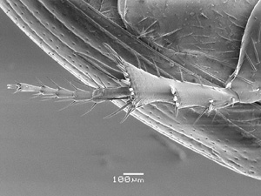 |  | 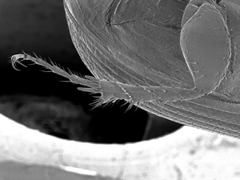
Figure 128. Xeropsamobeus doyeni. |  | Figure 129. Scabrostomus parapeculiosus, male.

85(83). Pronotum with complete, long, sparse setal fringe (Fig. 130). Body robust, black, elytra sometimes dark brown or with lighter markings. Pronotal disc only with coarse punctures, widely and irregularly spaced. Clypeus weakly emarginate. Northwestern North America …………………………………………. Phaeaphodius Reitter (in part)
85'. Pronotum with or without visible lateral setae; if setae visible then short or incomplete along length of margin. Body color variable. Pronotal disc usually with punctures evenly spaced, often of two sizes. Clypeus emarginate or not ………….. 86

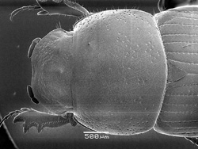
Figure 130. Phaeaphodius rectus.

86(85). Pronotum broad, usually explanate, often reflexed, with short, complete fringe of setae (Fig. 131). Male parameres with distinct dorsal or apical lobe. Western North America …………………………………………………… Agoliinus Schmidt (in part)
86'. Pronotum not explanate, occasionally broad, lacking setal fringe or with occasional setae visible. Male parameres with or without apical lobe [from this point, dorsal lobe on paramere present only in Agoliinus] ……………………………………………..… 87

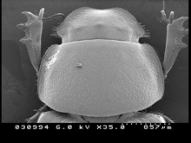
Figure 131. Agoliinus aquilonarius.

87(86). Elytron distinctly bicolored, with dark contrasting spots on a yellowish background (Fig. 132), or apex distinctly paler than base. Elytron with lateral fold lacking setae near base, few setae present at pronotal juncture. Body small, length less than 5 mm
…………………………………………………. Pardalosus Gordon and Skelley (in part)
87'. Elytron not distinctly bicolored; if bicolored, then lateral fold with distinct setae near base in addition to those at pronotal juncture. Body length variable, often more than 5 mm ……………………………………………………………………………………. 88

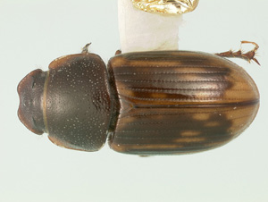
Figure 131. Pardalosus neodistinctus.

88(87). Clypeus with sparse setal fringe laterad of angulations (Fig. 133). Body entirely black dorsally, often with venter yellow or yellowâ€‘orange. North America and Mexico
…………………………………………………………… Pseudagolius Schmidt (in part)
88'. Clypeus lacking setal fringe. Body with dorsal color variable, venter never yellow-orange ………………………………………………………………………………… 89

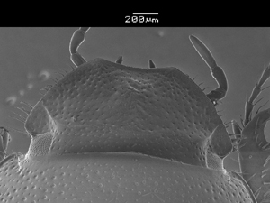
Figure 133. Pseudagolius coloradensis.

89(88). Clypeus with median frontal tubercle AND anterior margin distinctly angulate to toothed (Fig. 134) ……………………………………………………………………… 98
89'. Clypeus lacking above combination. Median frontal tubercle present or not. Clypeal margin occasionally angulate, rarely distinctly toothed ……………………………….. 90

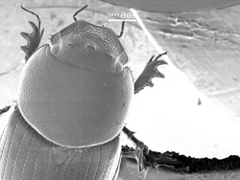
Figure 134. Oscarinus texensis.

90(89). Clypeal surface granulate (Fig. 135). Southeastern North America
………………………………….…………… Scabrostomus Gordon and Skelley (in part)
90'. Clypeal surface not granulate, often densely, coarsely punctate. Widespread …… 91

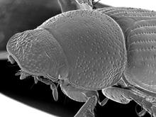
Figure 135. Scabrosomus bakeri.

91(90). Elytron distinctly bicolored or pale, contrasting with pronotum. Elytron occasionally with distinct pubescence on surface or declivity ………………………. 92
91'. Elytron at most with vague pattern, not contrasting in color with pronotum. Elytron never with distinct pubescence on surface or declivity ……………………………… 94

92(91). Clypeal apex nearly truncate or slightly emarginate (Fig. 136), lateral angles broadly rounded, lateral clypeal margin rounded to frontal lobe ……………………. 93
92'. Clypeal apex distinctly emarginate medially (Fig. 137), lateral angles narrowly rounded, lateral clypeal margin straight or sinuate ………………………………….. 98

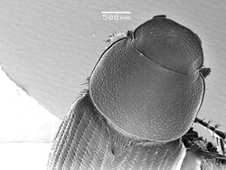 |  | 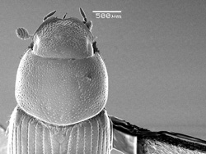
Figure 136. Melinopterus femoralis, female. |  | Figure 137. Oscarinus stuesseyi.

93(92). Elytron with distinct black markings (Fig. 138). Elytron lacking distinct dorsal pubescence ………………………………………….. Chilothorax Motschulsky (in part)
93'. Elytron entirely yellowish, or yellowish with single, large, vague central mark (Fig. 139). Elytral declivity and occasionally disc distinctly pubescent …Melinopterus Mulsant

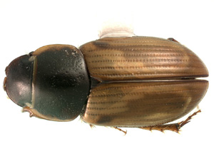
Figure 138. Melinopterus prodromus, female. |  | Figure 139. Melinopterus prodromus, female.

94(91). Head lacking distinct median frontal tubercle. Body usually reddish-brown …. 95
94'. Head with distinct median frontal tubercle. Body usually black ………………….. 97

95(94). Pronotum distinctly depressed before hind angle. Pronotal base thickly bordered. Male apical protibial spur lacking (female unknown). Brazil
………………………………………..… Ferrerianus Dellacasa, Gordon and Dellacasa
95'. Pronotum depressed before hind angle or not. Pronotal base thinly to moderately bordered. Male and female apical protibial spur present. North America to Mexico
………………………………………………………………………………………... 96

96(95). Meso- and metatibial apical spinules relatively short and unequal, not differing in length by more than half. Body black or nearly so, usually robust …………………. 98
96'. Meso- and metatibial apical spinules long and unequal, differing in length by more than half. Body usually brown or reddish, usually more flattened
……………………………………………………….. Geomyphilus Gordon and Skelley

97(94). Male and female protibial spurs long, surpassing anterior protibial tooth, female spur only slightly surpassing. Pronotal punctures evenly distributed, nearly uniform in size. Elytral intervals flat. Body black. Eastern North America
………………………………………………. Lechorodius Gordon and Skelley (in part)
97'. Lacking above combination of characters. Protibial spurs variable, usually not surpassing protibial tooth or only in males. Pronotal punctures often of two distinct sizes. Elytral intervals usually convex. Color black, red or brown, often with elytral spots …98

98(71', 89, 92', 96, 97'). Length usually less than 5.0 mm. Body short, robust; dorsal color uniformly black or brown, rarely entirely red. Pronotum robust, dorsum evenly convex in anterior view. Male inferior mesotibial spur unmodified. Male genitalia not strongly curved in lateral view, apex dorsoventrally flattened, without dorsal appendage (Fig. 140). Prairie states, southwestern and eastern North America, and Mexico
………………………………………………….. Oscarinus Gordon and Skelley (in part)
98'. Length usually more than 5.0 mm. Body elongate, robust; dorsal color variable, elytron often speckled. Pronotum not as robust, with dorsum weakly flattened in anterior view. Male inferior mesotibial spur modified. Male genitalia curved in lateral view, with dorsal appendage (Fig. 141). Widespread North America and Mexico, but not southeastern US …………………………………………….. Agoliinus Schmidt (in part)

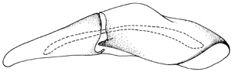
Figure 140. Oscarinus floridanus.
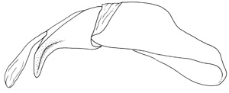
Figure 141. Agoliinus leopardus.

