Key to tribes and incertae sedis genera of New World Aphodiinae
(Skelley, 2007)

1. Head with labrum and mandibles clearly visible in anterior view (Fig. 1) ……….. 2
1'. Head with labrum and mandibles hidden under clypeus (Fig. 2) ………………..…3

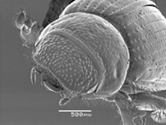 |  | 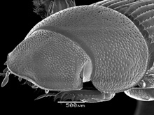
Figure 1. Aegialia sp. |  | Figure 2. Ataenius strigicauda

2(1). Pronotum evenly convex (Fig. 3). Elytral intervals all equally convex
…………………………………………………………………………... Tribe Aegialiini
2'. Pronotum with distinct ridges and grooves (Fig. 4). Alternating elytral intervals carinate ……………………….………….(Tribe Eupariini) Genus Annegialia Howden

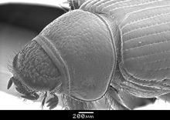 |  | 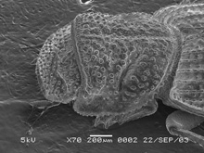
Figure 3. Aegialia argentina |  | Figure 4. Annegialia ataeniformis

3(1). Head distinctly rugose and setose (Fig. 5). Argentina (Tribe Aegialiini)
………………………………………….…. Genus Argeremazus Stebnicka and Dellacasa
3'. Head surface lacking distinct setae, or not from southern South America ………….. 4

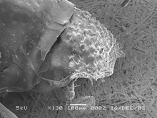
Figure 5. Argeremazus neuquen

4(3). Prosternal process projecting, hastate or stellate (Fig. 6). Meso- and metatibiae apparently lacking apical spurs. Pronotum and elytra deeply longitudinally ridged or grooved ……………………………………………………………………….………… 5
4'. Prosternal process not projecting, not hastate nor stellate (Fig. 7). Meso- and metatibiae with distinct apical spurs. Pronotum and elytra rarely longitudinally ridged or grooved (pronotum often transversely ridged) …………………………………………. 6

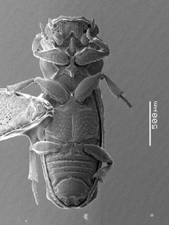 |  | 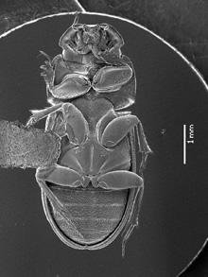
Figure 6. Leptorhyparus sp. |  | Figure 7. Ataenius strigicauda

5(4). Apex of elytra with large tuberculate prominences (Fig. 8), bearing trichomes. Pronotum appearing constricted at middle, with a transverse groove or row of deep pits
……………………………………………………………………….… Tribe Rhypariini
5'. Apex of elytra lacking large tuberculate prominences (Fig. 9). Pronotum not transversely constricted at middle ……... (Tribe Stereomerini) Genus Termitaxis Krikken

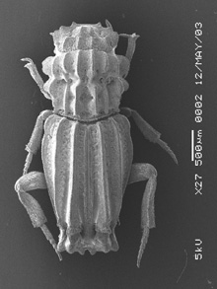 |  | 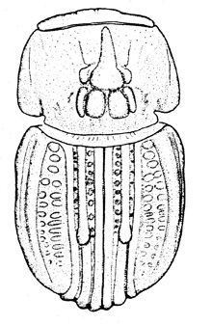
Figure 8. Aschnarhyparus peregrinus |  | Figure 9. Termitaxis holgreni

6(4). Elytral base lacking marginal bead. Elytral fold disappearing well before apex (Fig. 10). Pygidium entirely flat, unmodified by grooves or ridges. Femora never grooved on apical or posterior margins. Apical metatibial spurs usually separated by articulation of basal tarsal segment …………………………………………………………………... 7
6'. Elytral base with marginal bead. Elytral fold often attaining suture at apex, often thickened (Fig. 11). Pygidium modified with basal longitudinal groove that receives the elytra at rest, pygidium often with central transverse ridge and apical eroded area. Femora often with grooved margins. Apical metatibial spurs never separated by articulation of basal tarsal segment, spurs closely set at base and medial of tarsal articulation ….….. 9

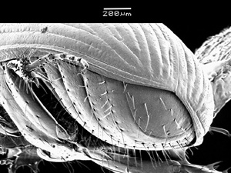 |  | 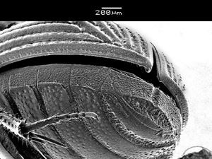
Figure 10. Aidophus parcus |  | Figure 11. Ataenius picinus

7(6). Apical metatibial spurs contiguous at base and medial of tarsal insertion (Fig. 12), which does not articulate between the spurs. Some abdominal sternites fused ………… 8
7'. Apical metatibial spurs more separated, closer to insertion of basal tarsal segment (Fig. 13), which articulates between the spurs. Abdominal sternites mostly freely movable ………………………………………………………………… Tribe Aphodiini

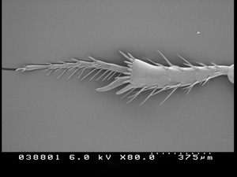 |  | 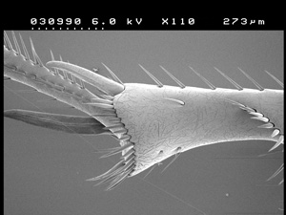
Figure 12. Aidophus parcus |  | Figure 13. Agoliinus cruentatus

8(7). Transverse carina on outer face of metatibia reduced, can be obsolete (Fig. 12). Body weakly convex, color pale yellow (Tribe Didactyliini) ………………………………………………………….…. Genus Aidophus Balthasar
8'. Transverse carina on outer face of metatibia distinct, strong (Fig. 14). Body strongly convex, color black (Tribe Proctophanini) ………. Genus Australaphodius Blackburn

 |  | 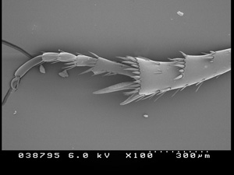
Figure 12. Aidophus parcus |  | Figure 14. Australaphodius frenchi

9(6). Apex of elytra with large bulbous process (Fig. 15) (Tribe Eupariini)
…………………………………………………………….. Genus Cartwrightia Islas
9'. Apex of elytra normal, lacking unusual processes (Fig. 16) ………………….. 10

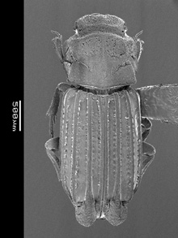 |  | 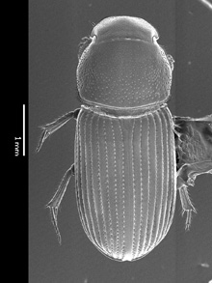
Figure 15. Cartwrightia cartwrighti |  | Figure 16. Ataenius picinus

10(9). Pronotum usually with transverse furrows separated by swellings (Fig. 17), furrows sometimes weak with only traces of impressions remaining, at least visible near eyes. Clypeus always granulate. Basal metatarsomere often shortened
………………………………………………………………………. Tribe Psammodiini
10'. Pronotum without transverse swellings, sometimes with weak transverse impressions or medial longitudinal depression (Fig. 18). Clypeus rarely granulate. Basal metatarsomere rarely shortened ………………………………………………………11

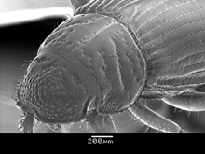 |  | 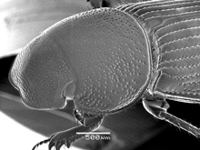
Figure 17. Leiopsammodius indefensus |  | Figure 18. Ataenius picinus

11(10). Pronotum not tumid (swollen), often flattened; moderately declivous laterally, lateral margin visible from above; lateral margin near base rarely eroded and toothed. Anterior clypeal margin rarely broadened and flattened laterally, often flattened medially; edge usually sharp or bluntly rounded laterally. Protibial teeth usually evenly spaced along margin ……………………………………………………………… Tribe Eupariini
11'. Pronotum robust, somewhat tumid anteriorly; sharply declivous laterally (Fig. 19), lateral margin usually not visible from above; lateral margin of pronotum usually eroded and often dentate near base. Anterior clypeal margin usually broad, flattened in front (Fig. 20) (most genera have a double edged clypeal margin). Protibial teeth often positioned more apically ………………………………………….. Tribe Odontolochini

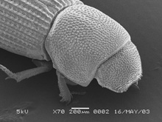 |  | 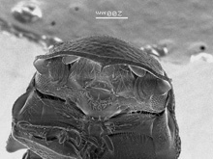
Figure 19. Saprositellus ariquemes |  | Figure 20. Saprolonchus sp.

