Key to genera of New World Aegialiini (Scarabaeidae: Aphodiinae)

1. Head with surface not setose, variously sculptured, may have with setal fringe on clypeus (Fig. 1) ……………………………………………………………………. 2
1'. Head with surface distinctly setose (Fig. 2) .. Argeremazus Stebnicka and Dellacasa

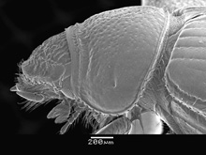 |  | 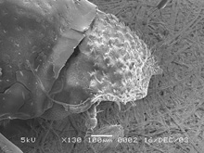
Figure 1. Aegialia argentina. |  | Figure 2. Argeremazus neuquen.

2(1). Elytral intervals with short hair. Abdominal sternites narrowed medially, fifth sternite obliterated at middle by sixth sternite (Fig. 3) ………….. Micraegialia Brown
2'.Elytral intervals lacking short hair. Abdominal sternites not narrowed medially, fifth sternite not obliterated at middle by sixth sternite …………………………………. 3

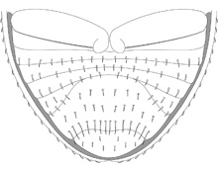
Figure 3. Micraegialia pusillus.

3(2). Elytral humerus dentate (Fig. 4). Body form parallel-sided …………………… 4
3'. Elytral humerus not dentate (Fig. 5). Body form elongate to globose …………… 5

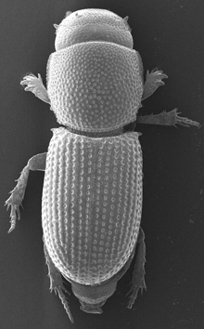 |  | 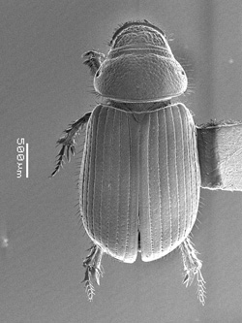
Figure 4. Amerisaprus valdivia. |  | Figure 5. Aegialia argentina.

4(3). Pronotum with posterior angle eroded, bearing several small teeth (Fig. 6). Apical metatibial spurs not separated at base. Body black. Chile …..Amerisaprus Stebnicka and Skelley
4'. Pronotum with posterior angle not notably eroded, lacking distinct teeth. Apical metatibial spurs separated at base by metatarsus. Body reddish-brown Western North America and Japan ………………………………………..……………… Caelius Lewis

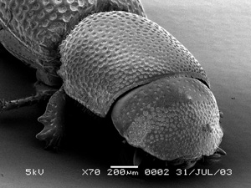
Figure 6. Amerisaprus valdiviana.

5(3). Maxillary palpus with terminal segment enlarged, widest at basal third, abruptly narrowed at base. Body red-brown. Body form notably elongate, almost parallel-sided. Basal marginal line of pronotum indistinct or lacking ……………….. Rhysothorax Bedel
5'. Maxillary palpus with terminal segment cylindrical. Body usually black, reddish-brown in some flightless members. Body form elongate to globose, but not parallel-sided. Basal marginal line of pronotum usually distinct, at least laterally ……. Aegialia Latreille

